PRACTICAL NO.1

PYTHON FUNCTIONS

PRINT FUNCTION:-

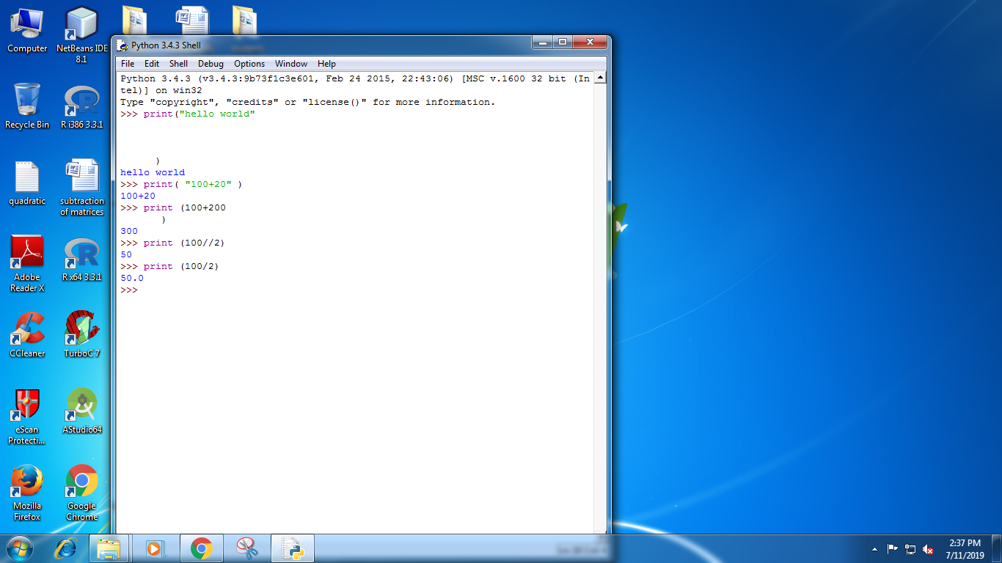

DELETE STATEMENTS:-

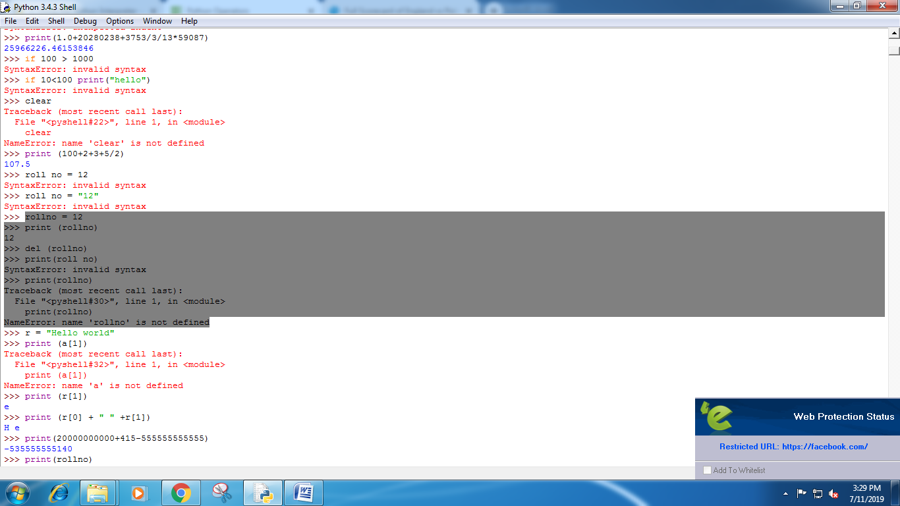

BOOLEAN STATEMENTS:-

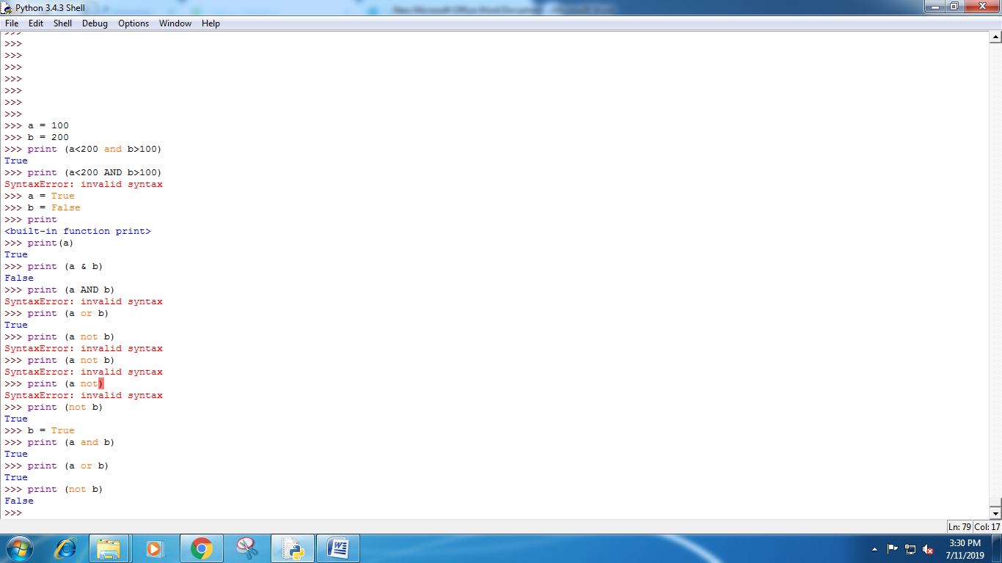

INPUT FUNCTION :-

